**I understand my difference**

**The doctor explains**

**why things are sometimes difficult for you.**



**

In your body, there are many cells.

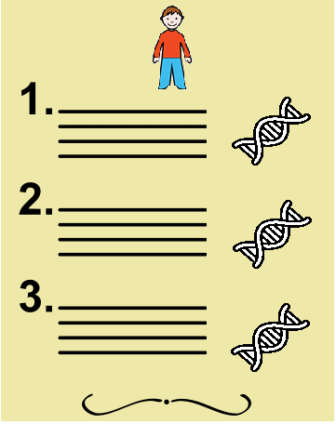

In each cell

there is a recipe for making you.



You met a doctor.

**C:\Users\GIOTGW\Downloads\genes.png**

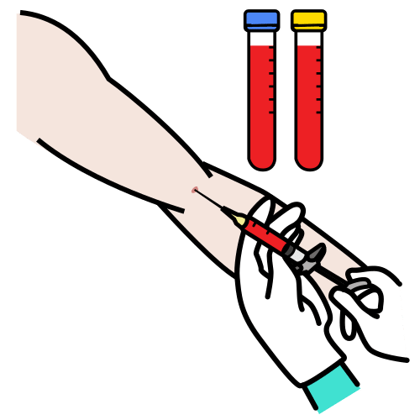

The doctor took some blood from you.



The doctor found a difference in the **MYT1L gene**.

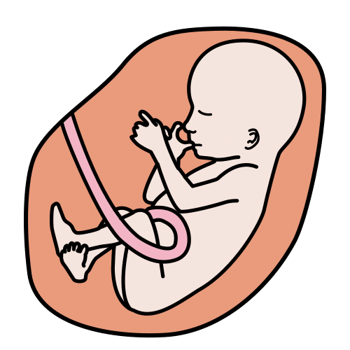

This difference happened

when you were made.



We can’t tell this difference on your face.



Some other people also have this difference.

**This difference can make things difficult for you.**

|  |  |
| --- | --- |
| * You may find it hard to articulate. |  |
| * You may find it hard to understand the things other people say to you. | C:\Users\GIOTGW\Downloads\parler (2).pngC:\Users\GIOTGW\Downloads\problème.png |
| * Les autres personnes peuvent avoir du mal à te comprendre. | C:\Users\GIOTGW\Downloads\ne pas comprendre (1).png |
| * You may find it hard to walk. | C:\Users\GIOTGW\Downloads\marcher.png |
| * You may be afraid of being high up. |  |
| * You may be afraid to sit on things that move. | C:\Users\GIOTGW\Downloads\se balancer.png |
| * You may not see well. | C:\Users\GIOTGW\Downloads\test de vue (1).png |
| * You may find it hard to write and draw. | C:\Users\GIOTGW\Downloads\écrire (1).pngC:\Users\GIOTGW\Downloads\colorier.png |
| * You may find it hard to cut. | C:\Users\GIOTGW\Downloads\découper.png |
| * You may find it hard to read. | C:\Users\GIOTGW\Downloads\lire (1).pngC:\Users\GIOTGW\Downloads\livre.png |
| * You may find it difficult to understand the things you read. | C:\Users\GIOTGW\Downloads\livre.pngC:\Users\GIOTGW\Downloads\problème.png |
| * You may find it hard to calculate. | **8 + 2 = 10** |
| * You may find it hard to read the numbers. |  |
| * You may need more time to work. | C:\Users\GIOTGW\Downloads\Time-Timer.png |
| * You may find it hard to do things on your own. | C:\Users\GIOTGW\Downloads\aide-médicopédagogique.png |
| * You may find it hard to get dressed. |  |
| * You may find it hard to wipe yourself in the toilet. |  |
| * You may want to eat all the time. | C:\Users\GIOTGW\Downloads\manger.png |
| * You may get fat faster than others. | C:\Users\GIOTGW\Downloads\grossir.png |
| * You may grow up faster than others. | C:\Users\GIOTGW\Downloads\grandir.png |
| * You can be very annoyed   or very angry. | C:\Users\GIOTGW\Downloads\faire un caprice.pngC:\Users\GIOTGW\Downloads\casser.pngC:\Users\GIOTGW\Downloads\donner un coup de pied dans la porte.png |
| * You may find it hard to wait. |  |
| * You may be often tired. | C:\Users\GIOTGW\Downloads\fatigué.png |
| * You may find it hard to fall asleep. | C:\Users\GIOTGW\Downloads\dormir.png |
| * You may wake up at night. | C:\Users\GIOTGW\Downloads\réveiller.png |
| * To make yourself feel comfortable, you can take up some habits. |  |
| * You can cover your ears if it's too loud. | C:\Users\GIOTGW\Downloads\mal à l'oreille.png |
| * You may want to do many things at the same time and too quickly |  |
| * Your body can shake a lot but you can’t stop it.   You may feel strange and fall to the ground.  This is an epileptic seizure |  |
| * Sometimes you have to go to hospital. | C:\Users\GIOTGW\Downloads\hôpital (1).png |
| * You may have to take medication | C:\Users\GIOTGW\Downloads\médicament.png |

**You can do many things with help**

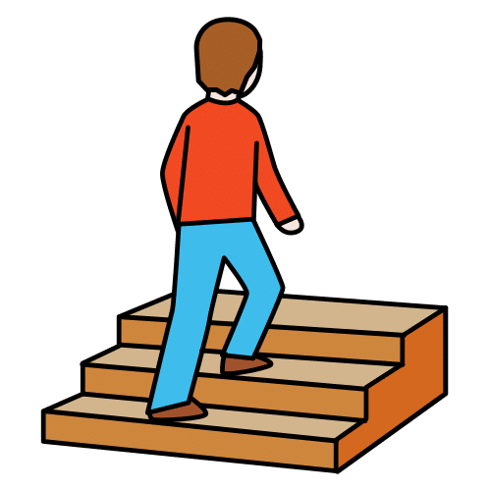

**and with extra time.**

**You will improve.**

**These things can help you.**

|  |  |
| --- | --- |
| To sit. |  |
| To get around:   * a tricycle * a special buggy | C:\Users\GIOTGW\Downloads\fauteuil roulant.pngC:\Users\GIOTGW\Downloads\tricycle.png |
| To get dressed, put on your shoes :   * velcro | C:\Users\GIOTGW\Downloads\enfiler les chaussures.png |
| To write and learn :   * a tablet * a computer * glasses |  |
| To get rid of noise :   * noise-cancelling headphones | C:\Users\GIOTGW\Downloads\casque anti-bruit.png |
| To communicate and sort yourself out :   * images |  |

**You can get help from people at home and elsewhere.**

|  |  |
| --- | --- |
| * Adults can help you. | C:\Users\GIOTGW\Downloads\homme adulte.png |
| * Friends can help you. | C:\Users\GIOTGW\Downloads\école primaire.png |
| * You may get a guide animal to help you. |  |
| * You can get help at school or at the center. | C:\Users\GIOTGW\Downloads\école.png |

**You can get help from doctors and specialists:**

|  |  |
| --- | --- |
| * a speech therapist   To speak better, count better, remember things,  sort yourself out... |  |
| * a physiotherapist   To have a stronger body.  To make your body hurt less.  To move in the way you want. | C:\Users\GIOTGW\Downloads\kinésithérapie.png |
| * an orthoptist   To see and read better. | C:\Users\GIOTGW\Downloads\test de vue.png |
| * a psychomotrician   To better concentrate and take care of your emotions,  to grab things better. | C:\Users\GIOTGW\Downloads\salle de psychomotricité.png |
| * an occupational therapist   To do things alone,  find the tools, how to grab. |  |
| * a psychologist   To chat, to help you feel good.  To understand how your brain works. |  |
| * a paediatrician   To see how you grow. |  |
| * a geneticist   To look at your cells and understand how you are made. |  |
| * other specialist doctors   For example, heart doctor,  food doctor,  back doctor. |  |

Author of the pictograms: [Sergio Palao](http://www.palao.es/) Source: ARASAAC [(http://www.arasaac.org)](http://www.arasaac.org/) License: [CC (BY-NC-SA)](http://creativecommons.org/licenses/by-nc-sa/3.0/es/) Ownership: Government of Aragon (Spain)

European Easy-to-Read Logo: Inclusion Europe.

More information on [www.inclusion-europe.eu](http://www.inclusion-europe.eu).

 

Author of the pictograms: [Sergio Palao](http://www.palao.es/) Source: ARASAAC